Research and development into Earthquake Detection and Alert Solution integrating Arduino-based IoT, Node.js, and Android

**Pabin Limbu**

LBU ID: 77203047

Production Project

Submitted for fulfillment of Bachelors (Hons.) in Computing

Submitted to: Saroj Kafle (Project Supervisor)

 

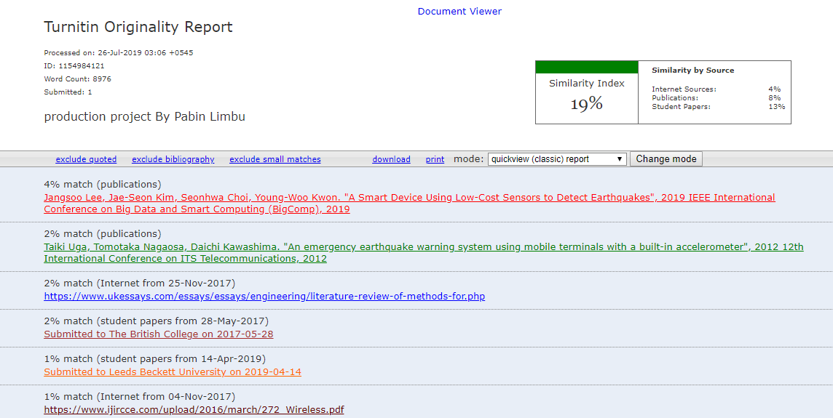

Table of Contents

Acknowledgement 3

Abstract 3

Chapter 1: Introduction 3

1. Statement of the problem 4

2. Aims of the project 4

3. Objective of this project 4

Chapter 2: Review of Literature 5

Chapter 3: Review of technology 10

Several technologies used for the development of this project is listed below: 10

1. Hardware component: 10

Framework: 11

Programing language: 11

Database: 12

Development tools: 12

Services: 13

Proposed and Applied methodologies: 14

Data Gathering: 14

Chapter 4: Software development methodology: 15

Research Findings: 16

Feasibility study: 16

Requirement analysis: 20

Software requirement: 20

Hardware requirement: 20

Functional requirement: 20

Non-functional requirement: 21

Prioritization: 22

MOSCOW prioritization: 22

Prioritizing functional requirement: 23

Prioritizing nonfunctional requirement: 23

Chapter 5: Design 24

1. Use case diagram: 24

2. Activity diagram: 25

3. Class diagram: 27

4. Database: 28

5. Hardware schematics: 29

Chapter 6: Implementation. 29

1. Hardware Implementation: 29

2. Front end Implementation: 30

3. Server-side Implementation: 30

Chapter 6: Testing. 30

1. White box testing: 30

2. Black box testing: 30

3. Test cases 31

Product Evaluation: 32

Conclusion 32

Future work 33

Biblography 34

Appendices 35

Meeting form. 35

Project plan. 41

# Acknowledgement

I am grateful to the British College in Kathmandu for giving me the environment and resources to conduct my final year’s production project.

Specifically, I am indebted to Mr. Saroj Kafle, who supervised me for this project. His untiring support from the conception to the delivery of my project is highly appreciated for life. Without his guidance, the project would prove daunting to accomplish.

Also, I would like to thank all the hard-working staffs in the student service department who administered my project and managed the logistics.

Lastly, I am thankful to my family, and my friends who motivated, inspired, and supported me to accomplish my undergraduate coursework with the strongest impetus.

# Abstract

Life manifests uncertainties in many forms. The deadliest being disasters. With the integration of sensor technologies, mobile computing and web servers, a complete solution for earthquake detection and notification is proposed and developed. Android is used for its ubiquitous distribution as a client device for receiving earthquake alert and responding with the safety status. The backend is developed using Node.js environment with mongo DB as the NoSQL database. To detect the tremble during earthquake, Arduino judiciously integrated with accelerometer is used. As a certain change in the X, Y, Z planar value is registered, the microcontroller triggers the web request at the server which further triggers the notification on the client’s Android phones. The responder then marks his/her safety status. The data can be visualized on an interactive map with geo location of earthquake detected and the responder’s whereabout.

# Chapter 1: Introduction

2019, with world plenty of modern equipment and technologies, still faces many problems during natural disaster. Earth quake the life threatening natural disaster has caused many destruction and loss of life over the year. The rate of earth quakes on current time with average of 2 rector scale magnitude occur several hundreds of time in a single day. Earthquake with the magnitude greater than 7 rector scale occur more than once over every month and the and the great earthquake with magnitude higher than 8 rector scale occur once per year in average. Earth being in an active state the earthquake is happening every now and then, National Earthquake Information Center locates that the occurrence of earthquake is about 12,000 to 14,000 per each year.

Earthquake detection and alert system is a system which integrates the concept of IOT “Internet of Things” Where machine to machine communication emerge, where various system like mechanical, computing, digital interrelates to perform certain task. The data is collected and transfer over the network without the involvement of human-to-human or human-to-computer interaction. Earthquake detection and monitoring model enables data collection from a sensor and send the particular data over the internet to remote server, saves the data to the database and notify users in mobile devices and also receive the response from users. For the detection of vibration, 3 axis accelerometer (GY- 600) sensor is used to sense data which is connected with the Arduino. Arduino being open source electronic platform it is easy to use hardware and software. Arduino holds the logic of processing received sensor data and sending it over the internet. Arduino acquiring accessible and simple user experience it is used over this project as hardware component to receive sensor data.

Earthquake detection and alert system includes the hardware component like Arduino, 3 axis accelerometers for sensing data. The node.js open source server environment is used to create web API server which helps to interact end devices (android device) with server and database. MongoDB document-oriented, no SQL database is used to store the data of Users and Earthquake.

A user will be registered through the android app as general user by providing their valid registration credentials, after the successful login of user the user will be notified when the orientation of accelerometer exceeds certain thresh hold level. User will then be able to respond to the app and provide their status as safe or unsafe. User can also add other user and check their status as safe or unsafe. This android application also registers admin user who can view the user’s safety report. Admin can view the user location, their status and update the safety status of user after the successful rescue of unsafe user.

Every people face different problem during earthquake like finding the earthquake victim to rescue, to check safety status of friends and family, this application helps people during the time of earth quake as it can help the rescue team to find the unsafe user quickly by viewing the unsafe users report through android app and helps to locate them accurately and quickly. It also helps to alert people during earthquake and view safety status of their friends and families.

This project intends to solve the real world problem faced during earthquake. Minimize the time consumed for searching and finding earthquake victim. Learning of new programming language and technology. Also intends to collaborate with various services working for rescuing and aiding earthquake affected victims.

## Statement of the problem

The rescue team face the great problem searching for earthquake victims as victim safety status and the location of victim is unknown. Unnecessary time is taken for searching the victim by the rescue team during earth quake. The structures are demolished and people are trapped under the rubbles and face loss of life due to late rescue. People are unable to know about the safety status of their friends and family.

## Aims of the project

* Generate the safety status report of the users which can be used by the rescue-oriented organization to help rescue team to respond quickly and accurately, save life of earthquake victim.

## Objective of this project

* Machine to machine communication.
* Sense the Vibration data and send it to Arduino.
* Send sensed data from Arduino to web server.
* Register user who can respond their safety status in system.
* Notify user during earthquake.
* View users last location.
* View safety status of friends and family.
* Get user response and update database.
* Make report of safe and unsafe users which will be used by the rescue team.
* Implementation and integration of different modules.
* Creating web API for android app

# Chapter 2: Review of Literature

Review on a **Smart Device to Detect Earthquakes Utilizing Low-cost Sensor** which were completed by a team of Jangsoo Lee1, Jae-Seon Kim2, Seonhwa Choi2, and Young-Woo Kwon1. Small handheld devices such as smartphones were used to detect earthquakes due to the significant growth of hardware and software systems in mobile and embedded computing. Within a smartphone, attempts have been made over the previous few years to detect earthquakes using low-cost acceleration detectors. However, using a smartphone to detect mere earthquakes is not only expensive, but also a waste of computing resources because smartphones come with a strong CPU, plenty of memory, and other additional sensors. A smartphone must also be linked to the Internet all the times. They present a stand-alone earthquake detection device with an acceleration sensor and Wi-Fi in this article.

First, by evaluating their output and precision to select the most appropriate acceleration sensor, they systematically assessed a set of accelerator sensors and then created a specific device that can sense earthquakes and send alerts to near appliances. In additional, they have used an Artificial Neural Network (ANN) method with the earthquake dataset acquires from the Pohang earthquake in South Korea, 2017 to differentiate earthquakes from daily movements. Their outcome demonstrates that a low-cost acceleration sensor can be used to detect an earthquake, thereby improving the safety of susceptible groups to earthquakes. Mobile phones including Internet of Things (IoT) and smartphones have developed significantly in both hardware and software over the past century. Such devices are often fitted with a multiple of sensors such as accelerometer, a GPS, a gyroscope, etc. and these sensors are commonly used to obtain helpful data (such as location-aware services), enhance user experiences (such as games), monitor their daily lives (such as health apps), etc.

In additional, there have been recent efforts to detect an earthquake using sensors inside the smartphone. In specific, by capturing sensor information from smartphones, MyShake can detect earthquakes. Two earthquakes have recently occurred: magnitude 5.6 in Gyeongju and in South Korea of 5.4 magnitude in 206 and 2017.

As a consequence, heavy demands were placed on detecting and reacting to earthquakes in a short time. One strategy is to use seismic networks based on smartphones, but using a smartphone to detect earthquakes and requesting volunteers to host their smartphones as a seismic sensor is expensive. In additional, because of the nature of smartphones that are used extensively in our everyday lives. Using a low-cost acceleration sensor and an earthquake detection algorithm, they had also introduced a smart device which can differentiate earthquakes from captured movements. They then describe how we chosen a suitable speed sensor.

Testing their sensors with two realistic earthquakes – 2017 Pohang and 1940 Centro – they then evaluated the experimental outcomes by comparing the initial input information (i.e. reference) and the information collected by each device. They have created an intelligent device that can be mounted on a wall or ceiling. Because the unit is fitted with only the requires sensors, including Wi-Fi, an accelerometer, etc. compared with a smartphone, its price is very small. We thoroughly assessed four distinct acceleration detectors to select a suitable one to determine the hardware specification of the earthquake sensors. The advanced earthquake detection and reaction system works as a stand-alone device while other methods require Internet links for further processing to work with a remote server or cloud

Finally, they tested our earthquake tracking algorithm using the dataset collected during the Pohang earthquake and instructed our system learning algorithm to track earthquakes in South Korea. The system that has been created offers three facilities. In case of an earthquake, the attached buzzer and LED will alert customer linked to the scheme. The program captures any changes in acceleration, and when observing shaking above a certain level (e.g. 0.02 g) operates the earthquake detection algorithm. In order to decrease false alarms, the system performs the earthquake tracking algorithm for seven seconds within two seconds of a time window, and if the outcome of the earthquake detection algorithm exceeds a certain limit during the specified time span, the present movement will be ascertained as an earthquake. Because the earthquake object tracking algorithm only classifies a present movement into an earthquake or non-earthquake movement, the magnitude of the detected earthquake must be calculated. However, using only one acceleration sensor, it is difficult to calculate the magnitude. Instead, by measuring PGA values, we calculate the present movement intensity and then send the intensity and then send the intensity level to neighboring devices such as smartphone or intelligent watches.(Lee, Kim and Choi, 2019)

--Review on an **Emergency Earthquake Warning System** which were completed by Taika Uga, Tomotaka Nagaosa and Daichi Kawashima where they have utilized **Mobile Terminals** with a **Built-in Accelerometer**. According to them, they have used portable terminals with an integrated accelerometer to study an emergency earthquake warning system. First, it is suggested to use the earthquake warning system that utilizes mobile terminals like smart phones as seismographs. The portable terminals detect seismic wave using an integrated accelerometer when an earthquake happens. If, acceleration value exceeds the threshold value, acceleration information will be transmitted on each region to a server. After that the server manages data sent by mobile terminals, presumes seismic intensity and hypocenter, and sends notification emails around the server to user terminals.

Since massive earthquake that directly attacks the metropolitan area is expected to occur in latest years, it is necessary to develop a sophisticated earthquake warning system. Although the Japan Meteorological Agency (JMA) provides the emergency earthquake warning, the output is not sufficient to send warning texts to the regions near the earthquake hypocenter.

That’s why there are a few observations and the alert system can’t send the alerts quickly. To fix this issue, JMA is trying to enhance the warning system. However, no effective warning system improvement technology is found, and owning to cost issues it is hard to raise the seismometers soon.

A popular acceleration sensor charged on personal device is used as a seismograph in earthquake observation systems to solve the shortage of seismographs. Quake-catcher Network is the large-scale earthquake observing network managed by Stanford University and UC Riverside using personal computers with an integrated accelerometer. Without a particular seismometer, this devise can detect earthquakes. Information on earthquake P2P is a personal earthquake warning system that uses P2P communication. Each node in this scheme distributes earthquake alert message to other nodes with P2P connection from JMA servers. Moreover, as a seismograph, this project attempted to use a programmable sensor board.

On the other side, the use of mobile terminals is explored using an integrated accelerometer to detect seismic wave. Tottori University is proposing a three-step seismograph using a smartphone. However, there is inadequate consideration of the emergency message dissemination system. The scheme suggested allows the earthquake observation point to be increased by using the accelerometer constructed in private appliances as a seismograph against the standard warning scheme.

When this system begins operating, a customer can guarantee their safety and prevent any vehicle accident that the drivers lost control of when the earthquake occurred. This is because this system can rapidly recognize shakes arriving at the observation region and can send alarm to each region. Due to a little shake induced by the earthquake, the car on highway in particular tends to be in risk. The system suggested for cars is therefore also efficient.

During implementation, the test uses private phone with Android OS as a customer. Android Dev in particular. Google’s phone and Sony Ericsson’s Xperia are used. In other words, GPS is fitted to acquire the present position and an accelerometer to acquire a personal device’s oscillation. Construction of the customer program was carried out using the Integrated Development Environments Java and Android on Eclipse.

Hence, the emergency earthquake alert system was researched using an acceleration sensor installed terminal. Specifically, they reviewed personal device efficiency with Android OS as a seismometer of acceleration data transmission. They have also built the server in the early warning dissemination scheme for the earthquake. Here, when people received the acceleration information and disseminated the alert text we confirmed the server’s processing ability.

As a consequence, they verified that, under ordinary conditions, the personal device observes acceleration near 20[gal] as a noise. Then a choice was made on an appropriate threshold value that utilizes the detection of earthquake tremors and confirmed that the personal device can spend to the server in emergency circumstances the acceleration information of tremor. (Mutuurahigashi, Yokohama and Kanagawa, 2012)

The FEMA 349 action plan (2000) provides an intelligent and economical strategy to enhancing the efficiency of the design and assessment scheme by building parties involved, including: owners, financial institutions, technicians, architects, contractors and scientists, the public and the governing authorities. The plan acknowledges the powerful need for more reliable, quantifiable and practical means to regulate construction harm from stakeholders ' organizations. It also acknowledges that among these organizations there is no focus on how to achieve these objectives. This plan explains how seismic design guidelines based on efficiency can be created and used to accomplish these objectives. ⠀

The document FEMA-273 (1997) offers technical guidance on the seismic renovation of structures and appropriate rules. The Seismic construction refurbishment Guidelines are designed for construction experts to use as a prepared instrument, as a reference document for building regulatory authorities and as a framework for future development and enforcement of regulations and norms for building codes. This document details various seismic building rates for structural and non-structural elements. It also provides various methods of analyzing seismic building rehabilitation.

The document ATC-40 (1996) offers a detailed technically sound suggested seismic assessment methodology and a new design of current concrete structures. Even if the design of new buildings is not intended, the analytical processes do apply. This document refers to the entire structural system and its parts and elements. The approach used here is performance: the assessment and retrofit design criteria are described as performance goals that define the required seismic level when the building is exposed to specific seismic terrain movement concentrations. Acceptable efficiency is evaluated by the amount of structural and/or structural harm that the earthquake shakes are anticipated to cause. Acceptable efficiency is evaluated by the amount of structural and/or structural harm that the earthquake shakes are anticipated to cause. Damage to different structural components and to the elements discovered in concrete structures in the post output, inelastic deformation limitations are articulated. The methodology includes the analytical process for post-elastic structure deformations, using streamlined non-linear static analysis techniques.

The standard FEMA-356 (2000) is designed for the seismic rehabilitation of current construction structures to be used as a national instrument for design experts, code officers and construction owners. The processes in this standard apply specifically to the rehabilitation of current structures and are generally more relevant than fresh building codes for that purpose. Advancing the seismic design processes of today's generation is commonly acknowledged as a critical next step in the nation's effort to create strong, loss-resistant communities in the earthquake engineering community. (UKEssays, 2019)

The work on "Magnitude analysis for earthquake detection with Primary Waves and Secondary Waves," proposed Narasimha Prasad L V Shankar Murthy P Kishor Kumar Reddy C. In these papers, earthquakes are a natural disaster known also as tremors or quake that occur because of the release of sudden energy, which is stored within stress areas in earth's crust. Due to stress imbalances, which produce three events called foreshock, primary shock, and aftershock, the stored energy is freed. Each event has waves like secondary waves, love waves, rayleigh waves, main waves and stoneley waves. As those waves travel from the inside of the earth to the ground, they degrade in magnitude and intense intensity, only part of the earth's surface is registered as a seismographer. To this date, many scientists have implemented various methods such as prediction based on radon emissions, prediction using instantaneous frequency extraction from subterranean water. As the earthquake happens through wave transmission, the effective strategy for predicting the earthquake is therefore a function of seismic signal extraction. Seismic signal parameters are evaluated with quick spectrum analysis by Fourier. The extent to which the analytical basis is based is used for earthquake detection. The smaller quakes are disregarded and the magnitude of the surface wave of the quakes which demonstrate an effect is calculated and discovered to be 4.0. Therefore, if the magnitude exceeds 4.0, the earthquake can be anticipated.

The work on "intensity assessments of earthquakes and harm detection using remote sensing data for global recovery" was proposed in Masafumihosokawa-pyojeong, Osameo takizawa. A fresh earthquake detection technique based on the mixture of both earthquake information (magnitude, source location, accurate ground conditions, remote attenuation equation) and the shift in SAR data will support worldwide rescue activities. Firstly, to discover collapsed buildings and homes that adopts a different picture on the surface of the earth.

The research on quality-driven volcanic earthquakes detection via wireless sensor networks was suggested by Rui Tan Guoliang Xing Jinju Chen Wen-Zhan SongRenjie Huang, and a new quality strategy for the identification of volcanic earthquakes in actual, on-site and long-lived sites has been suggested in this document. The strategy can fulfill stringent sensing quality standards (low false alarm / discrimination rate, and accurate earthquake start times) with low power consumption by deploying new network cooperative signal processing algorithms. The algorithms were implemented in TinyOS and a comprehensive test bed of 24 TelosB motes were evaluated and the actual traces were simulated on the active volcano during 5.5 months. This demonstrates that almost none of this approach results in false alarm / lacking frequency and a detection delay of less than one second, while the present information collection strategy achieves a 6-fold energy reduction.

Yong Deng, a senior structural engineer, has been investigating structural seismic problems. He researched that nonlinear time history analysis simulates structural conduct precisely as any other method under serious earthquake motion. His article has submitted one of the world-renowned projects to non-linear time history assessment. The San Francisco-Oakland Bay Bridge Project is part of Yerba Buena Island (YBI) West-Bound (WB) Ramps. The ramps from the YBI WB are extended by hinges to the Yerba Buena Island. This project is located at an earthquake safety assessment (SEE) site with a specific response of 0.627 g. YBI WB On-ramp has a curved bridge of 38.8 meters in a extremely horizontal direction. He said that for the project, seismic conduct is very essential. YBI WB On-ramp stand-alone bridge is evaluated by non-linear time history analysis technique in order to comprehend structural, non-linear conduct, particularly extremely horizontally curved bridge behavior in serious earthquake occurrences. For non-linear time history assessment, a software analysis program SAP 2000 is used for Hilber-Hughes-Taylor α direct integration. In this document too, seismic modeling is discussed. Then he used six sets of non-linear moment history analysis acceleration stories by SAP 2000. In this document, the precision of the non-linear time history analysis is also tested through a program established by the University of California-Berkeley. Also used for the assessment of the site Specific Response Spectra ARS are the outcomes of non-linear temporal assessment and the program established by California-Berkeley University. The assessment of the structural ability and ductility of serious seizure occurrences will then be conducted on a non-linéary push-over basis. Finally, discrepancies are debated and suggestions submitted between distinct programs analyzes. (P. Kamble, 2016)

# Chapter 3: Review of technology

The smartphones have been introducing approximately 26 years ago from today and since then many changes has been introduced in the development of mobile technology. Today’s smartphones are fast and can perform multiple task at a same time. The front end of this proposed application is developed as mobile application in android. Since Every people now a day have a smart phone with internet connectivity, which has helped this application to achieve in its reachability. As soon as the detection of earthquake the users can get the notification on their phone and respond to the notification and update their safety status.

As the development of seismology has not been evolved advanced enough to predict the earthquake before it occurs but the faster response can minimize the consequences of earthquake damage. Using smartphone will be the fastest means for the alert and response of safety status of user as smartphone is available to everyone.

Researcher at Berkeley university of California has released the app called my Shake which can help to detect earthquake using the accelerometer in smartphone and has also used the GPS to measure the shaking of the particular location but only with the sufficient download of the app by the people it can predict and detect more accurately and help for the early warning of earthquake. Likewise, this application uses the accelerometer but the accelerometer is used independently and not of smartphone as this system being prototype the accelerometer is used for this project temporarily. In future, the implementation of this project in real scenario will use seismograph as detection medium which is not feasible due to financial constraint now as a student. (Kong, 2015)

## Several technologies used for the development of this project is listed below:

### Hardware component:

**Arduino UNO:**

Arduino UNO is a micro controller board based on ATmega328p with several sets of digital and analog input/output pins available for expansion of various boards circuits and electronic components. The UNO series is the first in the series of USB based Arduino board. The sensor used in this project sends the data to the Arduino and the Arduino handles that data and sends it on the remote server. This board being best for the starters with the electronics and coding is used for this prototype project.

**GY-61 DXL 3-Axis Accelerometer module:**

GY-61 DXL 3-Axis Accelerometer is the sensor module based on ADXL 335 integration circuit. It is a triple axis accelerometer with extremely low power consumption and noise with sensing range of +/- 3g. With the help of its tilt-sensing capability and orientation detecting feature the acceleration of the gravity is measured while vibration of this sensor. When the tilting of the sensor crosses certain threshold, this application assumes the detection of earthquake and those data is sent to API server for further task processing.

### Framework:

**Express node.js Application Framework:**

Express node.js Framework is a flexible and minimal web application server framework providing robust set of features specially designed for building single, multi and hybrid web and mobile application. Its helps in the rapid development of node based web applications. Express framework is used in this project to build an Application programming Interface for the android device and Arduino. This API acts as a server to connect the mobile with remote server and Arduino with remote server. Express node.js framework allows to set middleware to respond to all HTTP request. Several routes have been defined in the Express file with the name “rout.js” where different HTTP requests are defined. so, when the end device sends any Http request the API server respond to its request

### Programing language:

**Node.js:**

Node.js is a runtime environment that executes the JavaScript code outside of a web browser. Quiet often we use node to build back end services. For this project we have used node for developing our application programming interface to power the client application. Client app used by the user interacts with the server to be subscribed to the services provided by the server. During the detection of earthquake this API helps to store, retrieve update data and also helps to push notification to android devices. The development of application with node is twice as fast and contain less line of code and files comparing to other languages and response much faster in comparison.

**JavaScript:**

Java script is a scripting language which is one of the most used and popular language and is very different than other programming languages like java. JavaScript allows to implements complex things on web pages and supported by most of the browsers and is growing faster than any other programming language. Primarily used for enhancing web pages and to provide more user friendly experience but the use of JavaScript won’t stop just there as in this project it is used to create a back end node server. Java script can support both front end/back end and full stack development of application.

**JAVA android:**

Android application developed for this project is written in java programming language. Java is an object oriented programming language widely used over the world. Java programming language is platform independent it can run on any platform like windows Linux etc. java is a strongly typed interpreted and compiled language with automatic memory management features.

**Arduino programming language:**

The Arduino programming language is a simple hardware programming language merely set of C and C++ language also called processing. The syntax of Arduino program is called sketch which include minimum of two block setup and loop. the setup block will execute first at the time of program execution and this function is called only once. All the initialization of pins and serial communication are initialized in this block. The second block is the loop where the code is executed in the loop and the core logic of the Arduino is written in this block. (HackerEarth Blog, 2019)

### Database:

**mongo DB:**

mongo DB is the no SQL, open source document-oriented database program. The mongo DB is very different from the traditional database system. The data saved in the mongo DB is in BSON (JSON like) format. mongo DB is light weight and is used widely. The growth of mongo DB is increasing rapidly comparing to other database system. The mongo DB database is independent of relational tables like traditional database system and is easy to use. This project use mongo DB to store the data of users and sensor. Mongo DB is easy to install and setup, mapping of the document is easy and scalable.

(SitePoint, 2019)

### Development tools:

**Arduino IDE:**

Arduino IDE v 1.8.9 is used to develop and write code for the Arduino device. This IDE runs on the various platform and this IDE can be used with any Arduino board.

**Postman:**

Postman v 7.3.4 is used as the API client to test the HTTP request and response to this web API. Postman API development environment is used by more than 7 million developers around the world it is easy to use and help for faster development and testing of API.

**Visual Studio code:**

Visual studio code v 1.36.1 is an open source light weight and powerful code editor. This code editor is used for the writing node JS and express code. Visual code Studio has a built in support for java script node JS and provide rich eco system for the extension of other languages. The user interface is simple and easy to use and navigate.

**Android Studio:**

Android studio v3.4.2 official android IDE built on jet-beans IntelliJ IDEA software specially designed for android development is used for this project for the development of android application used in this project. It is available for both mac and windows operating system. Android studio IDE is faster and more reliable compared to its native IDE Eclipse Android Development tool.

**GITHUB:**

GIT version control system is used in this project to track changes in source code during the development of this project. The code written and stored in a local repository is committed and pushed to the remote repository which can be pulled back to remote repository whenever needed. GIT helps to keep log of the changes in code and create a save point commit so, if any time user can revert back to that particular save point when necessary.

### Services:

**Google Map:**

Google map services developed by google is used as plugin in this android app to show the current location of the users registered in the system. It also allows to see the overview of all the safe and unsafe user with the marker containing user name.

**Firebase Cloud Messaging:**

FCM firebase cloud messaging is a service provided by google which is a cross platform messaging solution. FCM service is used in this project to notify user with notification when earthquake occur. Firebase cloud messaging service is free and reliable to use.

# Proposed and Applied methodologies:

After the devastating earthquake occurred in Nepal many people were injured thousands of people died only few were rescued. It took lots of time for the rescue team to locate the injured victims during the catastrophe. ABC news Nepal reported that the teen was carried out of the rubble after 5 days of earthquake occurrence and indiatodat.in reported that 3 survivors were pulled out alive after 8 days of earthquake. Like wise many people were trapped for several days and rescued, luckily some of the victims survived. This report shows that people were trapped in rubble for several days and lost their life. If those victims were rescued quick enough, they would have survived so, to make this quick rescue plan possible I have decided to choose this project. This project intends to help the people mark their safety and help rescue team to locate the victim quickly and accurately. (News, 2019)

## Data Gathering:

For this research study data collection was as important aspect as it helps understanding the core problem during disaster. The data gathering helped to perceive the importance of this application during earthquake. With the research and data collection it was known that the survivor rate was low because the rescue team was unaware about the trapped victim and their location.

Focused Group:

A group of participants who experienced the earthquake damage were questioned with the multiple solution to apply during the earthquake and the “quick response and rescue” option was in the highest priority among other options.” To know the safety status of people and their location” was also in the priority among the other options.

Observation:

Noticing that many people during earthquake were saved several days after they were trapped which shows that rescue team were unaware or unknown about the trapped victim and their location. After studying multiple news report of earthquake rescued people it has shown that the rescue team faces the problem to locate victim and also state that people has to lose their life due to late rescue. It also unveils that the rate of rescue is very low.

Prototyping:

As prototyping is the release of application in production phase where evolution of product debugging and fixing may occur before the deployment of final product. Prototyping is also called the beta phase of application. This application is developed using the prototyping methodology. All the modules are developed individually and integrated to each other. While prototyping this application, the application was divided into smaller module. Each module was developed and integrated with one another. During the integration fixing of errors and debugging was carried out.

# Chapter 4: Software development methodology:

During the ongoing project development many changes in requirement can be encountered by the developer. Traditional waterfall method lacks the feature to over come the problem of frequent change in requirement so to address this problem the iterative waterfall model is used which is almost the same methodology as waterfall but more efficient for software development. Iterative waterfall model does not attempt to start the development with the full specification of requirement. Instead the development is started with the implementation of the part of software which is then reviewed and further requirements are identified, these processes is repeated and the new version of software is produced in each iteration of this model.

Iterative waterfall model introduces the feedback path so, when the error or the changes has to be done in later phase these feedback path allows developer to revert back to the previous committed changes and fix it or change it. Iterative waterfall model is easy to Implement and understand and is one of the most used software development models.

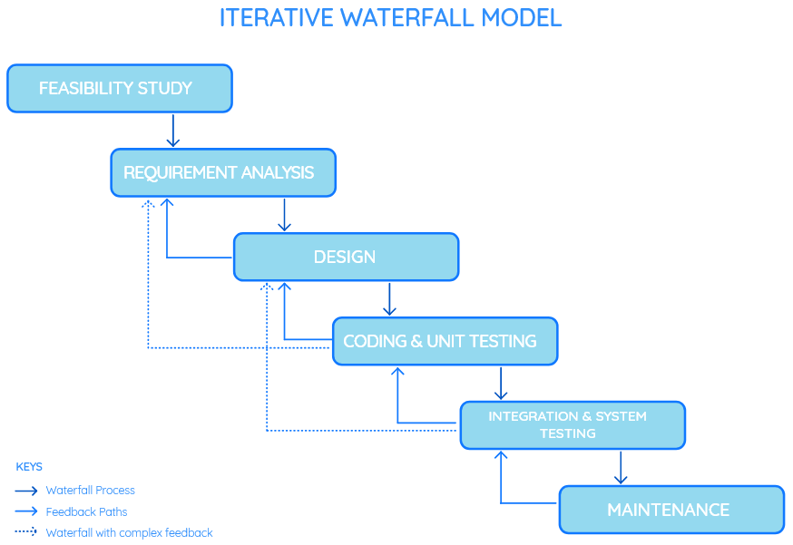

## Research Findings:

### Feasibility study:

The analysis of feasibility of this project is done in the early stage of product development to know and evaluate if the project is going to be possible or not. Feasibility study accounts all aspect of development, it estimates the essential resource required, level of expertise required, legal requirement, social aspect including quantitative and qualitative assessment of every essential resources, general timetable and cost estimation etc. Feasibility study also determines the project value its rate of return in investment and the estimated cost of the project development.

The feasibility study carried out for this project are listed below:

**Technological feasibility study.**

Technical feasibility is the most important criteria to be considered as it is the study of the project in terms of technical aspect of project including all input, output, procedure and program. Technical requirement helps us to measure the available technical resources including all hardware and software resources which is needed during the development of the project.

The software used for the development of this project is open source and free and all the hardware used are inexpensive and are easily available in market. With the availability of all the required technological requirement this project is technologically feasible.

**Economic feasibility study.**

Resources used while learning different programming languages like books and internet is provided by the British College and the technical support and module guide is also provided by the college. Expenses for used hardware were inexpensive and the software’s used for the development are free. This project being self-developed no extra human resource is hired. So, the cost for the development of this project is minimal, due to which this project is financially feasible.

**Operational feasibility study.**

Since this application for end user is simple to use in terms of usability. The users have to install one time and signup themselves and all work is done by the application. This application has simple user interface. Setting up the back end of this application is easy and one-time setup since there won’t be any difficulties while operating this application so, it is considered as operationally feasible.

**Scheduling feasibility study.**

Feasibility study has accessed the potential time frame and completion dates for the major activities within this project meets the institutional deadline and constraints. With the Gantt chart the analysis of project time frame is done and sufficient time is provided for completion of every activity of the project.

The total time for the completion of this project is well planned and the timeline for each activity, milestone is provided in a Gantt chart. with the availability of sufficient time for the completion of this project this project is considered as scheduled feasible. (iamglyka, 2019)

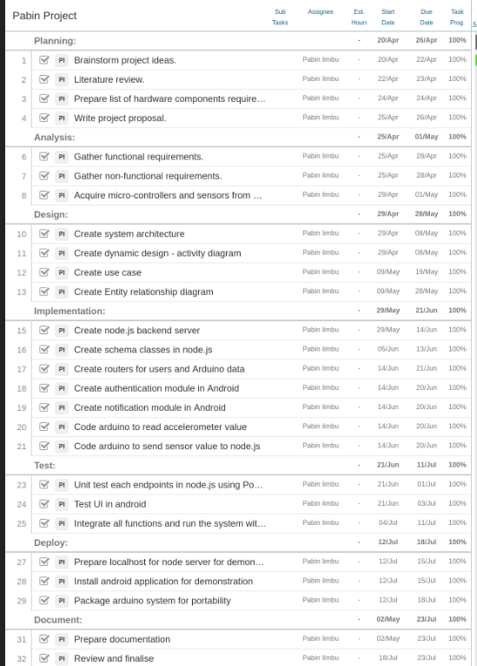

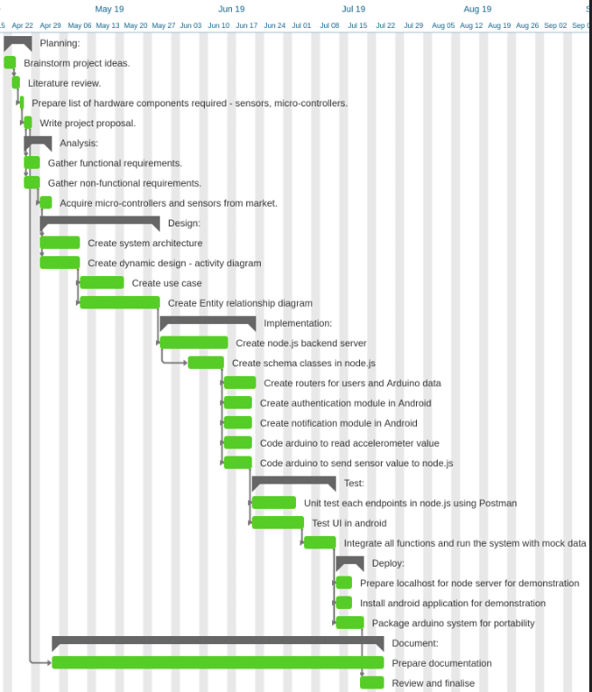

## Requirement analysis:

All functional/non-functional, hardware and software requirements for the development of this project was analyzed during the analysis phase. Requirement analysis lets us determine what functionality and features should the application acquire and to build that application what hardware and software are needed. It also helps us to evaluate the expertise required during the project development. Requirement analysis resolves the problem of conflict and ambiguity of required features in application which may occur during the development phase.

### Software requirement:

|  |  |
| --- | --- |
| Operating system | Windows 7 or higher |
| Text editor | Visual Studio code |
| API development Environment | Postman |
| Arduino IDE | Arduino IDE |
| Android Development Environment | Android studio |
| Database | Mongo DB |

### Hardware requirement:

|  |  |
| --- | --- |
| Micro controller | Arduino UNO |
| Sensor | ADXL335 GY-61 3-Axis accelerometer |
| RAM | 2 GB and above |
| HDD | 5 GB minimum |
| Jumper wire | M-to-M and M-to-F |
| Node MCU | ESP826 micro controller (WIFY module + Arduino) |
| Bread board | Medium size circuit board |

### Functional requirement:

The major behavior and functionality of this project is stated in the functional requirement table.

|  |  |  |  |
| --- | --- | --- | --- |
| ID | Functionality | Description | Dependencies |
| FR1 | Receive acceleration data | Accelerometer sense acceleration data which is received by the Arduino. |  |
| FR2 | Check acceleration threshold | When acceleration data is received Arduino check its threshed hold. | FR1 |
| FR3 | Send acceleration data to web | When acceleration data cross certain threshold level the data is sent to web. | FR1, FR2 |
| FR4 | Listen HTTP request | API listen to all the HTTP request requested by Arduino and mobile. |  |
| FR4 | Save acceleration data to database | When API receive the request the acceleration data is saved to the database. | FR1, FR2, FR3 |
| FR5 | Register User | Get user credentials and send it to web API. |  |
| FR6 | Login User | With valid credentials user can log in into system. | FR5 |
| FR7 | View user location | Admin can view user current location of users registered in system. | FR5 |
| FR8 | View user list | Admin can view the list of users registered in the system. | FR5 |
| FR9 | View safe user | Admin can view safe user in map and in list. | FR5 |
| FR9 | View unsafe user | Admin can view unsafe user in map and list. | FR5 |
| FR10 | Notify user | System will notify user when accelerometer data is greater than given thresh hold. | FR5 |
| FR11 | Receive User Status | User update their safety status to system. | FR5, FR10 |
| FR12 | Add User | User can add other user who are registered in system. | FR5 |
| FR13 | Show graph | Admin can view the graph of earthquake pattern | FR1, FR2 |

### Non-functional requirement:

Non-functional requirement states the functions which directly affects the user experience.

|  |  |  |  |
| --- | --- | --- | --- |
| ID | Title | Description | Dependencies |
| NFR1 | Security | Only valid users have access to system, only Admin can view user location |  |
| NFR2 | Reliability | System should provide accurate location of user and their status. | NRF1 |
| NFR3 | Usability | User interface should be simple. |  |
| NFR4 | maintainability | system is built using framework and is modular which makes it maintainable in future | NRF3 |

## Prioritization:

## MOSCOW prioritization:

Moscow prioritization technique is used for the prioritization of all functional and nonfunctional requirement of this project as the project is released modularly. With each release the features and function are added in the application. This prioritization technique helps to identify the significance of each functionality according to their priority and importance. This prioritization technique separates the functionality in terms of their importance. The category of prioritization includes must have functionality, should have functionality, could have functionality and functionality which will not be included this time. (Productplan.com, 2019)

**Prioritization category:**

1. **Must have requirement.**

The most important functions are categorized under must have category and are mandatory for the developer to complete. Without the completion of this functionality the application cannot be released as the product wont work without this functionality. These functionalities are the most vital and should be completed before the product release.

1. **Should have.**

Should have functionality are just a step below must have functionality. Should have functionality are completed in later release without impacting the current application. Before the release of final product, the “should have functionality” are completed as this functionality are important for the complete product but not vital. Application can perform certain task without these functionalities. Some of the functionality like bug fixing, extra features, feature improvement are categorized under this priority.

1. **Could have.**

Could have also known as nice to have category holds the functionality which if implemented can add extra features to the application. Compared to the “should have” category the “could have” functionality has much smaller impact on the outcome of product even if it is left out.

1. **Won’t have.**

This category holds the functionality and features which won’t be included in the release of final product. Functionality which lies beyond the scope of this project but can be implemented in the future are prioritized under this category.

## Prioritizing functional requirement:

|  |  |  |
| --- | --- | --- |
| ID | Requirement | MOSCOW prioritization |
| FR1 | Receive acceleration data | Must have |
| FR2 | Check acceleration threshold | Must have |
| FR3 | Send acceleration data to web | Must have |
| FR4 | Listen HTTP request | Must have |
| FR4 | Save acceleration data to database | Must have |
| FR5 | Register User | Must have |
| FR6 | Login User | Must have |
| FR7 | View user location | Must have |
| FR8 | View user list | Should have |
| FR9 | View safe user | Should have |
| FR9 | View unsafe user | Must have |
| FR10 | Notify user | Must have |
| FR11 | Receive User Status | Must have |
| FR12 | Add User | Should have |
| FR13 | Show graph | Won’t have |
| FR14 | Keep log of earthquake | could have |
| FR15 | Trigger alarm | Could have |

## Prioritizing nonfunctional requirement:

|  |  |  |
| --- | --- | --- |
| ID | Title | MOSCOW prioritization |
| NFR1 | Security | should have |
| NFR2 | Reliability | must have |
| NFR3 | Usability | Should have |
| NFR4 | maintainability | Could have |

# Chapter 5: Design

## Use case diagram:

Use case diagram is produced for this project to illustrate the graphical representation of user interaction with system.

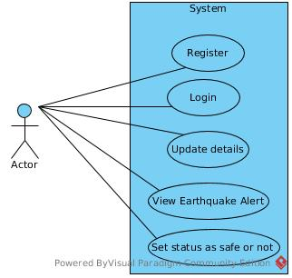

## Activity diagram:

Activity diagram is a UML diagram produced to show the interaction and flow of one activity to another activity. It shows how the operation are executed and the condition are applied for the flow of execution.

**User registration and login.**

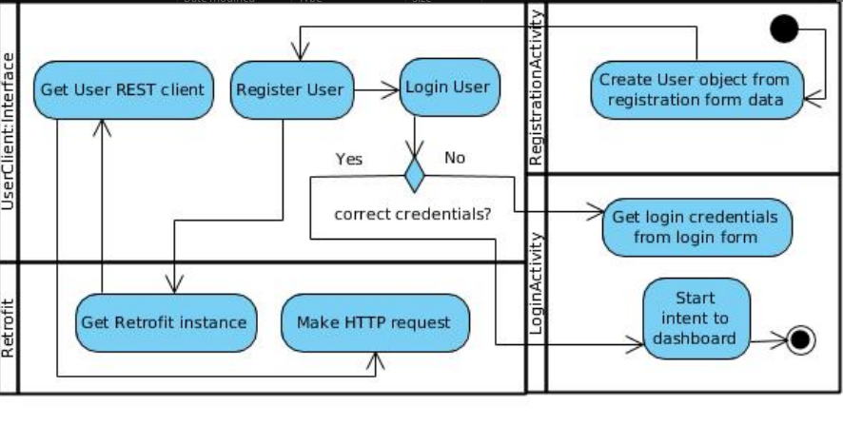

**Earthquake detection and notification.**

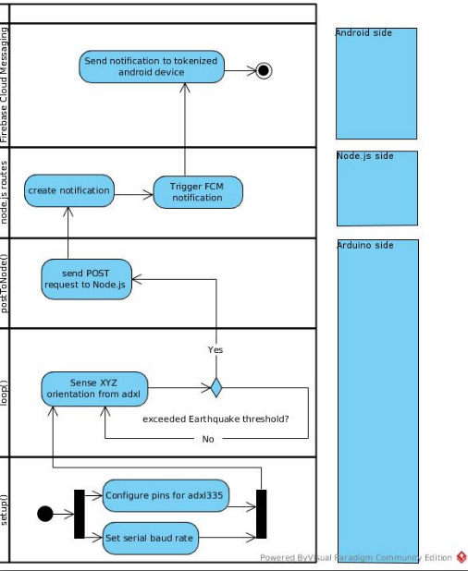

## Class diagram:

Class diagram is a UML diagram produced to illustrate the relationship between model’s object. Class diagram helps developer to produce code based on the relationship of model it shows the overview of application architecture and its core business logic.

Initial class diagram.

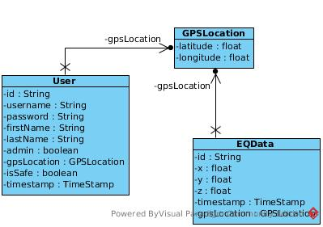

## Database:

Mongo DB database is use as database in this project which is document oriented no SQL database. Mongo DB stores data in JSON like format and is easy to read and implement. Mongo DB is light weight flexible and reliable comparing to another database. The structure of the data to be stored in mongo DB is defied in mongo schema. Figure given below shows how the data are saved in mongo DB database.

Mongo DB structure.

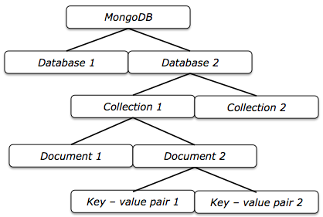

## Hardware schematics:

This schematic shows how the ADXL335 gy-61 Accelerometer is connected to the Arduino micro controller. It shows the route of the accelerometer pin joined the Arduino input pin.

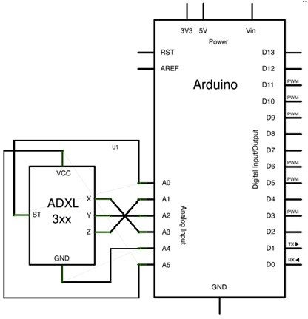

# Chapter 6: Implementation.

After completion of the design phase the implementation part is carried out. This part of report shows how the overall project was implemented, what programming languages were used and how the system was integrated.

The implementation of this application is divided into three parts hardware implementation, front end development and server-side development.

## Hardware Implementation:

ADXL335 GY-61 3-Axis accelerometer have 5 pins x, y, z output pin including one VCC voltage collector pin and one ground pin the x-axis output pin is connected to the A0-input pin, y-axis output pin is connected to the A1-input pin and z-axis output pin is connected to the A2 input pin of Arduino board. The ground pin is connected to the ground pin of Arduino and the VCC pin of accelerometer is connected to the Arduino pin which provide 3.3volt electric current to the accelerometer.

After the connection of accelerometer with Arduino the software for the Arduino to fetch data and send it to server is written in Arduino programming language which is similar to c language. Arduino programming language is simple to implement and understand. The syntax written in Arduino programming language is also known as sketch. Sketch contain minimum of two block setup and loop.

The initialization of pins and libraries are defined in setup block and the core logic are written in loop block. The setup block is executed once and the loop block executes over and over again.

## Front end Implementation:

For end user the android application is developed where user can register themselves and logged in into system. User will then be notified when the earthquake is detected and user can then send response if they are safe or not. If user failed to response the notification even after the given time then that user will be registered as unsafe user.

The implementation of android application is written in java programming language. MVC pattern is followed for development of android application. Several dependencies are added while implementing android code. Google map service is implemented in android application for fetching user’s location and showing their mark on map. FCM firebase cloud messaging service is implemented in android application to notify user from remote server.

## Server-side Implementation:

Server-side application web API is written in java script scripting language. Node express which is server-side environment framework is used for the development of web API. Express environment defines the routes for all models which listen to the HTTP request requested by client and respond back. Express web API saves the data sent form android and Arduino to the mongo DB database.

# Chapter 6: Testing.

The testing of application is carried out along with the code Implementation. Before releasing the working application, the application was tested thoroughly. Testing technique implemented for this application are:

## White box testing:

While white box testing the internal code was tested using j unit testing framework. All the function written inside the code was tested.

## Black box testing:

Black box testing does not know about the internal function and how its logic is written. Black box testing only check if the input and evaluates the expected output over real output.

## Test cases

Test case is prepared to test the expected result and actual result of the application.

|  |  |  |  |  |  |
| --- | --- | --- | --- | --- | --- |
| SN | Test | Input | Expected result | Actual result | remarks |
| Test case 1 | registration | user name  password  first name  last name  location | Add new user | User added | passed |
| Test case 2 | login | User credential | Login valid user | User logged in | passed |
| Test case 3 | Fetch accelerometer data | X, y, x -Axis data | Accelerometer data fetched | Accelerometer data fetched | passed |
| Test case 4 | Save accelerometer data | Save data to database | Save data to database | Data saved | passed |
| Test case 5 | Send notification | User revive notification | User receive notification | Notification received by user | passed |
| Test case 6 | respond as safe | User register safety status | User status updated in database | Status saved in database | passed |
| Test case 7 | View user location | View location of user in map | Plot user location in map | User location plotted in map | passed |
| Test case 8 | Add user as friend | Add user | Send friend request | Friend request sent | passed |

# Product Evaluation:

The product was evaluated using usability testing conducted by a number of lay users selected in the British College premise.

The steps included in this process are:

* Planning the usability tests.
* Tasks and functional goals were assigned.
* Participants are randomly selected
* Marking rubric for usability developed
* Rubric filled by the participants.
* Analysis of data from the survey acquired.
* Decisions taken to improve the usability.

The questionnaires were filled by the participants and the product was rated to be usable with little training.

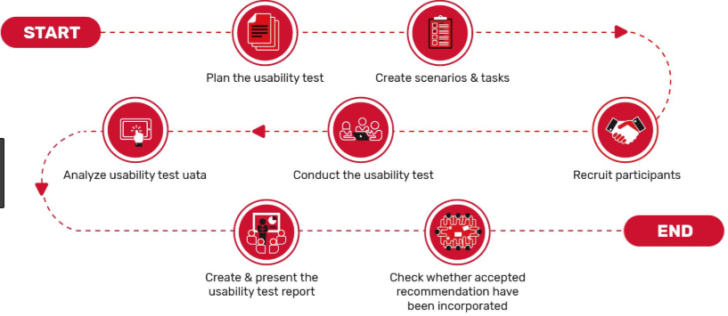  
*Screenshot: Usability Testing*

# Conclusion

The proposed solution for earthquake detection and notification was achieved using IoT, Android, and Node server. This was a cost-effective and efficient solution that can be quickly deployed on the field. The sensor technology for tremble detection was selected to be the accelerometer. This was integrated with NodeMCU Arduino microcontroller. The design involved structural and dynamic aspects of the system including design of the hardware setup and the architectures and dynamic flow of data within the system.

The front end was developed in Android where the user can register their details with the locations. The backend was developed using Node.js platform. The APIs were exposed and JSON data was consumed from the Arduino and Android device. The Arduino pushed the earthquake detection via the NodeMCU and accelerometer sensor. Three different technologies namely, mobile computing, web server, and sensors were integrated to design and develop the disaster detection and alert system.

# Future work

# Biblography

Lee, J., Kim, J. and Choi, S. (2019).

A Smart Device Using Low-cost Sensors to Detect Earthquakes.

Mutuurahigashi, M., Yokohama, Y. and Kanagawa, K. (2012).

*An Emergency Earthquake Warning System Using Mobile Terminals with a Built-in Accelerometer*. japan: International Conference on ITS Telecommunications.

P. Kamble, P. (2016).

*Wireless Sensor Networks for Earthquake Detection and Damage Mitigation System*. Amravati, India: International Journal of Innovative Research in Computer and Communication Engineering.

UKEssays, U. (2019).

*Literature Review of Methods for Earthquake Analysis*. [online] UKEssays.com. Available at: https://www.ukessays.com/essays/engineering/literature-review-of-methods-for.php?fbclid=IwAR2sa8x_ONRZ0Swhb5ahT8OMIk250D3o1tb_5iQ5QMqBX5_6ZEvhi1cdWf8 [Accessed 25 Jul. 2019].

Kong, Q. (2015). *MyShake – A smartphone app to detect earthquake*. [online] researchgate.net.

Availableat:https://www.researchgate.net/publication/301613128_MyShake-A_smartphone_app_to_detect_earthquake

[Accessed 9 Apr. 2019].

HackerEarth Blog. (2019). *Arduino programming for beginners*. [online] Available at: <https://www.hackerearth.com/blog/developers/arduino-programming-for-beginners/>

[Accessed 10 Apr. 2019].

SitePoint. (2019). *An Introduction to MongoDB — SitePoint*. [online]

Available at: <https://www.sitepoint.com/an-introduction-to-mongodb/>

[Accessed 11 Apr. 2019].

News, A. (2019). *Teen Rescued From Rubble 5 Days After Earthquake*. [online]

ABC News. Available at: <https://abcnews.go.com/International/nepal-earthquake-teen-rescued-days-trapped-rubble/story?id=30694907>

[Accessed 12 Apr. 2019].

iamglyka. (2019). *schedule feasibility*. [online] Available at: <https://iamglyka.wordpress.com/2013/02/06/schedule-feasibility/>

[Accessed 12 Apr. 2019].

Productplan.com. (2019). *What is MoSCoW Prioritization? | Overview of the MoSCoW Method*. [online] Available at: <https://www.productplan.com/glossary/moscow-prioritization/>

[Accessed 13 Apr. 2019].

# Appendices

## Meeting form.

|  |  |  |  |
| --- | --- | --- | --- |
| **School of Computing, Creative Technologies and Engineering**  **Level 6 Production Project** | | | |
| **MEETING RECORD SHEET:** | | | **Meeting**  **Number:** |
| **Student: Pabin limbu** | | **Student I.D.:77203047** | |
| **Date of Meeting:10 feb 2019** | | **Supervisor: saroj kafle** | |
| **Actions agreed at previous meeting (completed or comment):** | | | |
| **1** | **◻** | | |
| **2** | **◻** | | |
| **3** | **◻** | | |
| **4** | **◻** | | |
| **5** | **◻** | | |
| **6** | **◻** | | |
| **Comments of student (if any):**  ………………………………………………………………….…………………………..……………………………………….................  ………………………………………………………………….…………………………………………………………………….................  ………………………………………………………………….…………………………………………………………………….................  ………………………………………………………………….…………………………………………………………………….................  ………………………………………………………………….…………………………………………………………………….................  ………………………………………………………………….…………………………………………………………………….................  ………………………………………………………………….…………………………………………………………………….................  ………………………………………………………………….…………………………………………………………………….................  ………………………………………………………………….……………………………………………………………………................. | | | |
| ***ABOVE here*** *– student to complete before Meeting with supervisor.* ***BELOW here*** *– complete at the Meeting.* | | | |
| **Next meeting** (date/time)**:** | | | |
| **Agreed Actions to complete before next meeting:** | | | |
| **1** | **Initial project plan is discussed.** | | |
| **2** | **Project final project specification document** | | |
| **3** |  | | |
| **4** |  | | |
| **5** |  | | |
| **6** |  | | |
| **Comments of supervisor (if any):**  ………………………………………………………………….…………………………………………………………………….................  ………………………………………………………………….…………………………………………………………………….................  ………………………………………………………………….…………………………………………………………………….................  ………………………………………………………………….…………………………………………………………………….................  ………………………………………………………………….…………………………………………………………………….................  ………………………………………………………………….…………………………………………………………………….................  ………………………………………………………………….…………………………………………………………………….................  ………………………………………………………………….…………………………………………………………………….................  ………………………………………………………………….……………………………………………………………………................. | | | |

Second meeting

|  |  |  |  |
| --- | --- | --- | --- |
| **School of Computing, Creative Technologies and Engineering**  **Level 6 Production Project** | | | |
| **MEETING RECORD SHEET:** | | | **Meeting**  **Number:** |
| **Student: pabin limbu** | | **Student I.D.: 77203047** | |
| **Date of Meeting:22 feb 2019** | | **Supervisor: saroj kafle** | |
| **Actions agreed at previous meeting (completed or comment):** | | | |
| **1** | **◻** | | |
| **2** | **◻** | | |
| **3** | **◻** | | |
| **4** | **◻** | | |
| **5** | **◻** | | |
| **6** | **◻** | | |
| **Comments of student (if any):**  ………………………………………………………………….…………………………..……………………………………….................  ………………………………………………………………….…………………………………………………………………….................  ………………………………………………………………….…………………………………………………………………….................  ………………………………………………………………….…………………………………………………………………….................  ………………………………………………………………….…………………………………………………………………….................  ………………………………………………………………….…………………………………………………………………….................  ………………………………………………………………….…………………………………………………………………….................  ………………………………………………………………….…………………………………………………………………….................  ………………………………………………………………….……………………………………………………………………................. | | | |
| ***ABOVE here*** *– student to complete before Meeting with supervisor.* ***BELOW here*** *– complete at the Meeting.* | | | |
| **Next meeting** (date/time)**:** | | | |
| **Agreed Actions to complete before next meeting:** | | | |
| **1** | **Present literature review and methodology.** | | |
| **2** | **Identify project finding and project feasibility.** | | |
| **3** |  | | |
| **4** |  | | |
| **5** |  | | |
| **6** |  | | |
| **Comments of supervisor (if any):**  ………………………………………………………………….…………………………………………………………………….................  ………………………………………………………………….…………………………………………………………………….................  ………………………………………………………………….…………………………………………………………………….................  ………………………………………………………………….…………………………………………………………………….................  ………………………………………………………………….…………………………………………………………………….................  ………………………………………………………………….…………………………………………………………………….................  ………………………………………………………………….…………………………………………………………………….................  ………………………………………………………………….…………………………………………………………………….................  ………………………………………………………………….……………………………………………………………………................. | | | |

|  |  |  |  |
| --- | --- | --- | --- |
| **School of Computing, Creative Technologies and Engineering**  **Level 6 Production Project** | | | |
| **MEETING RECORD SHEET:** | | | **Meeting**  **Number:** |
| **Student: pabin limbu** | | **Student I.D.: 77203047** | |
| **Date of Meeting:8th march 2019** | | **Supervisor: saroj kafle** | |
| **Actions agreed at previous meeting (completed or comment):** | | | |
| **1** | **◻** | | |
| **2** | **◻** | | |
| **3** | **◻** | | |
| **4** | **◻** | | |
| **5** | **◻** | | |
| **6** | **◻** | | |
| **Comments of student (if any):**  ………………………………………………………………….…………………………..……………………………………….................  ………………………………………………………………….…………………………………………………………………….................  ………………………………………………………………….…………………………………………………………………….................  ………………………………………………………………….…………………………………………………………………….................  ………………………………………………………………….…………………………………………………………………….................  ………………………………………………………………….…………………………………………………………………….................  ………………………………………………………………….…………………………………………………………………….................  ………………………………………………………………….…………………………………………………………………….................  ………………………………………………………………….……………………………………………………………………................. | | | |
| ***ABOVE here*** *– student to complete before Meeting with supervisor.* ***BELOW here*** *– complete at the Meeting.* | | | |
| **Next meeting** (date/time)**:** | | | |
| **Agreed Actions to complete before next meeting:** | | | |
| **1** | **Start design phase of project.** | | |
| **2** | **Start implementation phase for prototyping.** | | |
| **3** |  | | |
| **4** |  | | |
| **5** |  | | |
| **6** |  | | |
| **Comments of supervisor (if any):**  ………………………………………………………………….…………………………………………………………………….................  ………………………………………………………………….…………………………………………………………………….................  ………………………………………………………………….…………………………………………………………………….................  ………………………………………………………………….…………………………………………………………………….................  ………………………………………………………………….…………………………………………………………………….................  ………………………………………………………………….…………………………………………………………………….................  ………………………………………………………………….…………………………………………………………………….................  ………………………………………………………………….…………………………………………………………………….................  ………………………………………………………………….……………………………………………………………………................. | | | |

## Project plan.

|  |  |  |
| --- | --- | --- |
| **Sc(Hons) Computing Course 2018/19**  **Level 6 Production Project** | | |
| **Name: Pabin limbu** | **Student I.D.: 3017** | |
| **Course: BSc(Hons) Computing** | **Supervisor’s Name: Pranita Upadhya** | |
| **FINAL PROJECT INDIVIDUAL AIM & OBJECTIVES** | | |
| **Title of my Project: Earthquake detection and alert system using IOT.** | | |
| **Aim of my Project:** Design earthquake detection and alert system, monitor safety status. | | |
| **Objectives of my Project:**   * Produce conceptual rich picture of the proposed project. * Produce Architectural and behavioral model of system. * Learn how to collect and process data from sensor and Arduino device. * Fast detection of people and their location that need rescue. * minimize the consequences of earthquake. * Trigger alarm automatically when vibration is sensed by sensors. * Notify user when earthquake is detected. * Record user safety status in database. * Learn Arduino programming and python programming language. * Learn different design pattern.   Product specification:  Earthquake detection and alert system is a prototype which is developed to model, evaluate and test the system which can ensure the safety of human life during earthquake. Hardware used in this project are sensors, Arduino device, internet, end devices alarm beeping speaker. Machine to machine communication aids this project to successfully gather and process data.  Sensors gather data and sends to micro controller which process the data, trigger alarm and sends details about the area of affected place to server. When earthquake is detected people will be alerted through alarm and notified through mobile app. Status received from client will be used to generate report which can be used for quick rescue plan.  MoSCoW method:  Since the functionality and requirement are well known MoSCoW prioritization is used to prioritize requirement in category. (W3schools.com, 2018)  Must have:  Minimum usable subset is kept under this category. Proposed project cannot achieve its aim without this following requirement.  User registration.   |  |  |  | | --- | --- | --- | | SN | Requirement | MoSCoW | | 1 | User login. | Must have. | | 2 | Measure acceleration force | Must have. | | 3 | Process data receive from sensor. | Must have. | | 4 | Ask user if they are safe or not through mobile app. | Must have. | | 5 | Update user safety to database if they are marked as safe or not. | Must have. | | 6 | Availability | Must have. |   Should have:   |  |  |  | | --- | --- | --- | | SN | Requirement | MoSCoW | | 1 | Notify user through mobile app. | Should have. | | 2 | Triger safety alarm automatically. | Should have. |   Could have:   |  |  |  | | --- | --- | --- | | SN | Requirement | MoSCoW | | 1 | Keep log of earthquake magnitude force | Could have. | | 2 | User friendly GUI. | Could have. | | 3 | Security in login. | Could have. | | 4 | Password inscription. | Could have. |   Won’t have this time. | | |
|  | | |
| **Research**  This project idea is extracted from the concept of smart housing with IOT. Earthquake detection and alert system is a part of smart house, it intends to save people lives by alerting them during earthquake. This research will be done for earlier detection of earthquake.  Research on using Arduino device, programming on Arduino and 3 axis accelerometer sensors will be carried out. Various types of seismic wave will be reviewed and researched, these data will be used to match and record the nature of earthquake in database. Online courses provided by edx.org , coursera.org and Documentation provided by python software foundation and w3c web tutorials will be used as online resource to this project. | | |
| **Methods of Production Evaluation**   * Prototyping of the modelled system will be produced which will be followed by questioners and evaluate its functionality with check list will be carried out. | | |
| **PROJECT PLANNING and METHODOLOGY** | | |
| **PROJECT PLANNING:**      **METHODOLOGY**  **Since the requirement of this project is well identified and technology used for the development of this project is available, iterative waterfall module is used for the development of this project.** | | |
| **RESOURCES** | | |
| **The hardware and software I require to complete my Project successfully:** | | |
| Item (Hardware or Software)  **Hardware:**  Arduino Uno.  Accelerometer sensor.  Alarm beeping speaker.  **Software:**  NetBeans IDE.  XAMPP web server solution.  OS-Windows 10.  Visual studio community edition. | | Source:  Own.  Own.  Open source.  Open source.  Own.  Open source. |
| **HUMAN RESOURCE** | | |
| **I am working on my Project with the following people** | | |
| **Name: Pranita Upadhya** | **Role:**  Module Leader  Supervisor | |
| The British College Staff |
|  | | |
| **INITIAL BIBLIOGRAPHY**  Coursera. (2018). *Arduino Courses | Coursera*. [online]  Available at <https://www.coursera.org/courses?query=arduino>  [Accessed 24 Oct. 2018].  edX. (2018). *edX*.  [online] Available at: <https://www.edx.org/>  [Accessed 24 Oct. 2018].  Docs.python.org. (2018). *3.7.1 Documentation*.  [online] Available at: <https://docs.python.org/3/>  [Accessed 24 Oct. 2018].  W3schools.com. (2018). *W3Schools Online Web Tutorials*.  [online] Available at: <https://www.w3schools.com>  [Accessed 24 Oct. 2018].  Agile Business Consortium. (2018). *DSDM Atern Handbook (2008)*.  [online] Available at: <https://www.agilebusiness.org/content/moscow-prioritisation-0>  [Accessed 24 Oct. 2018].  international, o. (2018).  [online] Available at: <https://www.omicsonline.org/open-access/disaster-early-warning-systems-in-nepal-institutional-and-operational-frameworks-2167-0587-1000196.php?aid=88818>  [Accessed 1 Dec. 2018].  Ammon, C. (2018). *Arduino | GEOSC 109H – Earthquakes & Society*.  [online] Sites.psu.edu. Available at: <https://sites.psu.edu/geosc109h/category/arduino/https://sites.psu.edu/geosc109h/category/arduino/>  [Accessed 1 Dec. 2018].  Seismonepal.gov.np. (2018). *National Seismological Center*.  [online] Available at: <http://seismonepal.gov.np/earthquakes>  [Accessed 1 Dec. 2018].  Scecinfo.usc.edu. (2018). *Locating and measuring earthquakes - Putting Down Roots in Earthquake Country*.  [online] Available at: <http://scecinfo.usc.edu/eqcountry/roots/measuring.html>  [Accessed 1 Dec. 2018].  Saraò, A., Clocchiatti, M., Barnaba, C. and Zuliani, D. (2018). *Using an Arduino Seismograph to Raise Awareness of Earthquake Hazard Through a Multidisciplinary Approach*.  [online] Academia.edu. Available at: <http://www.academia.edu/20444553/Using_an_Arduino_Seismograph_to_Raise_Awareness_of_Earthquake_Hazard_Through_a_Multidisciplinary_Approach>  [Accessed 2 Dec. 2018].  allen, r. (2018). [online] Rallen.berkeley.edu.  Available at: <https://rallen.berkeley.edu/research/eew/docs/AllenEEWScientificAmericanApr2011.pdf>  [Accessed 2 Dec. 2018].  Fass o, A. (2018). *A statistical approach to crowdsourced smartphone-based earthquake early warning systems*. [online] Arxiv-export-lb.library.cornell.edu. Available at: <http://arxiv-export-lb.library.cornell.edu/pdf/1512.01026>  [Accessed 2 Dec. 2018]. | | |